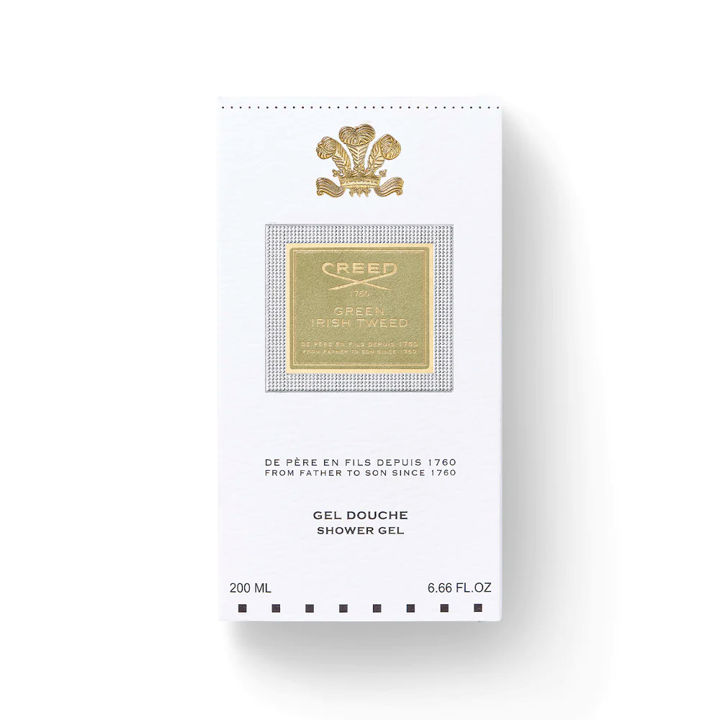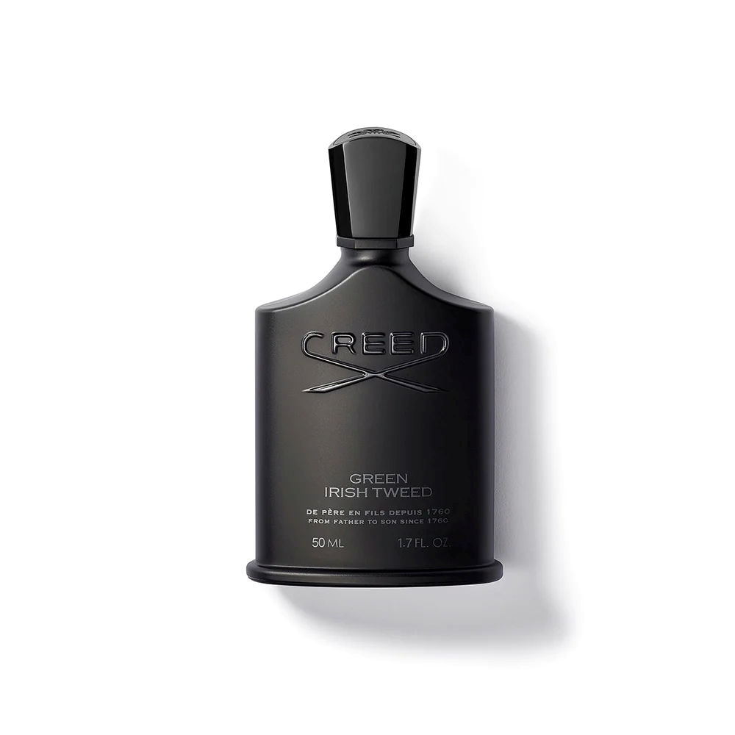

**CREED GREEN IRISH TWEED**

$470.00

Tax Included.

Spray 100 mL

IN STOCK

### Product Details

Like a perfectly tailored suit, Green Irish Tweed has been, and continues to be, worn by confident men at the peak of their field.

The fragrance elegantly combines woody freshness and pure masculinity, equally suited to a stroll through the Irish countryside and a strut down the red carpet.